Kongu Engineering College

Deep Skilling – Engineering Concepts
Design Patterns and Principles

EX 1:
class Logger {
private static Logger instance;
private Logger() {
System.out.println("Logger Created");
}
public static Logger getInstance() {
if (instance == null) {
instance = new Logger();
}
return instance;
}
public void log(String message) {
System.out.println("LOG: " + message);
}
}
public class SingletonPattern {
public static void main(String[] args) {
Logger log1 = Logger.getInstance();
Logger log2 = Logger.getInstance();
log1.log("Application Started");
System.out.println("Same Instance: " + (log1 == log2));
}
}
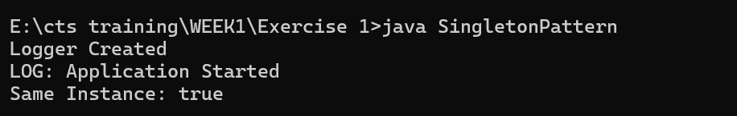
EX 2:
interface Document {
void open();
}
class WordDocument implements Document {
public void open() {
System.out.println("Opening Word Document");
}
}
class PdfDocument implements Document {
public void open() {
System.out.println("Opening PDF Document");
}
}
class ExcelDocument implements Document {
public void open() {
System.out.println("Opening Excel Document");
}
}
abstract class DocumentFactory {
abstract Document createDocument();
}
class WordFactory extends DocumentFactory {
public Document createDocument() {
return new WordDocument();
}
}
class PdfFactory extends DocumentFactory {
public Document createDocument() {
return new PdfDocument();
}
}
class ExcelFactory extends DocumentFactory {
public Document createDocument() {
return new ExcelDocument();
}
}
public class FactoryMethodPattern {
public static void main(String[] args) {
DocumentFactory factory = new PdfFactory();
Document doc = factory.createDocument();
doc.open();
}
}
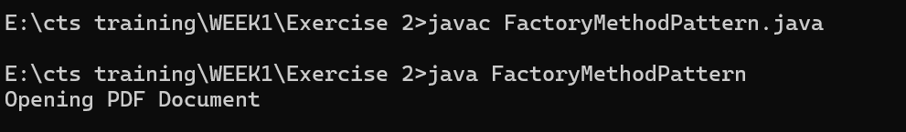
EX 3:
class Computer {
private String cpu;
private int ram;
private int storage;
private Computer(Builder builder) {
this.cpu = builder.cpu;
this.ram = builder.ram;
this.storage = builder.storage;
}
public void display() {
System.out.println("CPU: " + cpu);
System.out.println("RAM: " + ram + " GB");
System.out.println("Storage: " + storage + " GB");
}
static class Builder {
private String cpu;
private int ram;
private int storage;
public Builder setCPU(String cpu) {
this.cpu = cpu;
return this;
}
public Builder setRAM(int ram) {
this.ram = ram;
return this;
}
public Builder setStorage(int storage) {
this.storage = storage;
return this;
}
public Computer build() {
return new Computer(this);
}
}
}
public class BuilderPattern {
public static void main(String[] args) {
Computer pc = new Computer.Builder()
.setCPU("Intel i7")
.setRAM(16)
.setStorage(512)
.build();

pc.display();
}
}
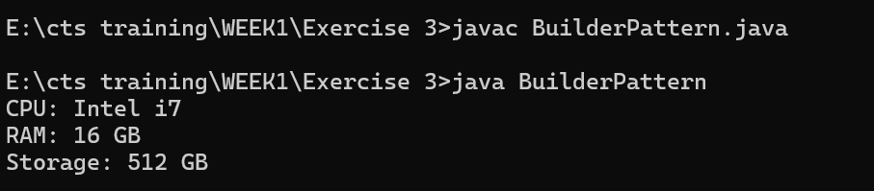
EX 4:
interface PaymentProcessor {
void processPayment(double amount);
}
class PayPalGateway {
public void makePayment(double amount) {
System.out.println("Payment through PayPal: Rs." + amount);
}
}
class PayPalAdapter implements PaymentProcessor {
private PayPalGateway gateway;
public PayPalAdapter(PayPalGateway gateway) {
this.gateway = gateway;
}
public void processPayment(double amount) {
gateway.makePayment(amount);
}
}
public class AdapterPattern {
public static void main(String[] args) {
PaymentProcessor payment =
new PayPalAdapter(new PayPalGateway());
payment.processPayment(1000);
}
}
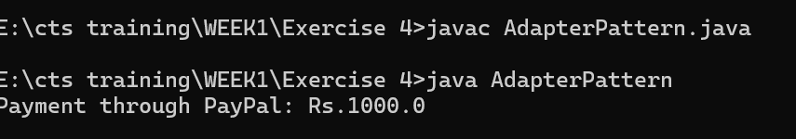
EX 5:
interface Notifier {
void send(String message);
}
class EmailNotifier implements Notifier {
public void send(String message) {
System.out.println("Email Notification: " + message);
}
}
abstract class NotifierDecorator implements Notifier {
protected Notifier notifier;
public NotifierDecorator(Notifier notifier) {
this.notifier = notifier;
}
}
class SMSNotifierDecorator extends NotifierDecorator {
public SMSNotifierDecorator(Notifier notifier) {
super(notifier);
}
public void send(String message) {
notifier.send(message);
System.out.println("SMS Notification: " + message);
}
}

class SlackNotifierDecorator extends NotifierDecorator {
public SlackNotifierDecorator(Notifier notifier) {
super(notifier);
}
public void send(String message) {
notifier.send(message);
System.out.println("Slack Notification: " + message);
}
}
public class DecoratorPattern {
public static void main(String[] args) {
Notifier notifier =
new SlackNotifierDecorator(
new SMSNotifierDecorator(
new EmailNotifier()));
notifier.send("Meeting at 10 AM");
}
}
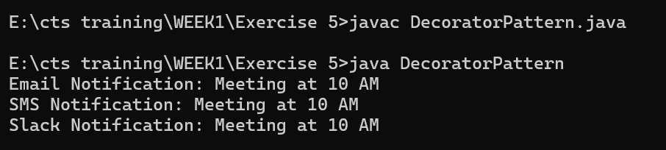
EX 6:
interface Image {
void display();
}
class RealImage implements Image {
private String fileName;

public RealImage(String fileName) {
this.fileName = fileName;
loadImage();
}
private void loadImage() {
System.out.println("Loading image from server: " + fileName);
}
public void display() {
System.out.println("Displaying image: " + fileName);
}
}
class ProxyImage implements Image {
private RealImage realImage;
private String fileName;
public ProxyImage(String fileName) {
this.fileName = fileName;
}
public void display() {
if (realImage == null) {
realImage = new RealImage(fileName);
}
realImage.display();
}
}
public class ProxyPattern {
public static void main(String[] args) {
Image image = new ProxyImage("sample.jpg");
image.display();
image.display();
}}
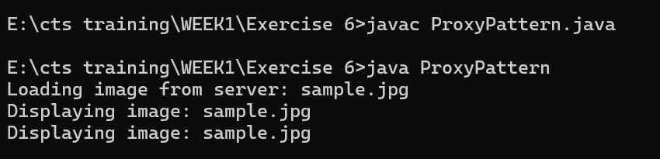
EX 7:
import java.util.*;
interface Observer {
void update(double price);
}
interface Stock {
void registerObserver(Observer o);
void removeObserver(Observer o);
void notifyObservers();
}
class StockMarket implements Stock {
private List<Observer> observers = new ArrayList<>();
private double stockPrice;
public void setStockPrice(double price) {
stockPrice = price;
notifyObservers();
}
public void registerObserver(Observer o) {
observers.add(o);
}
public void removeObserver(Observer o) {
observers.remove(o);
}
public void notifyObservers() {
for (Observer o : observers) {
o.update(stockPrice);
}
}
}
class MobileApp implements Observer {
public void update(double price) {
System.out.println("Mobile App: Stock Price Updated to " + price);
}
}
class WebApp implements Observer {
public void update(double price) {
System.out.println("Web App: Stock Price Updated to " + price);
}
}
public class ObserverPattern {
public static void main(String[] args) {
StockMarket market = new StockMarket();
Observer mobile = new MobileApp();
Observer web = new WebApp();
market.registerObserver(mobile);
market.registerObserver(web);
market.setStockPrice(2500.50);
}
}
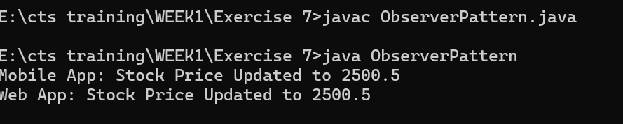
EX 8:
interface PaymentStrategy {
void pay(double amount);
}
class CreditCardPayment implements PaymentStrategy {
public void pay(double amount) {
System.out.println("Paid Rs." + amount + " using Credit Card");
}
}
class PayPalPayment implements PaymentStrategy {
public void pay(double amount) {
System.out.println("Paid Rs." + amount + " using PayPal");
}
}
class PaymentContext {
private PaymentStrategy strategy;
public PaymentContext(PaymentStrategy strategy) {
this.strategy = strategy;
}
public void executePayment(double amount) {
strategy.pay(amount);
}
}
public class StrategyPattern {
public static void main(String[] args) {
PaymentContext context =
new PaymentContext(new CreditCardPayment());
context.executePayment(5000);
context =
new PaymentContext(new PayPalPayment());
context.executePayment(3000);
}
}
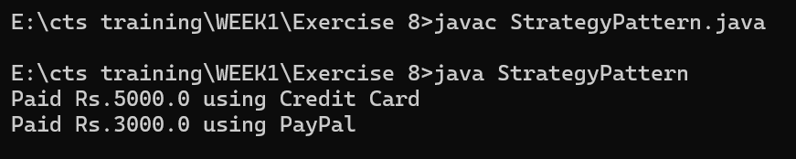
EX 9:
interface Command {
void execute();
}
class Light {
public void on() {
System.out.println("Light is ON");
}
public void off() {
System.out.println("Light is OFF");
}
}
class LightOnCommand implements Command {
private Light light;
public LightOnCommand(Light light) {
this.light = light;
}
public void execute() {
light.on();
}
}
class LightOffCommand implements Command {
private Light light;
public LightOffCommand(Light light) {
this.light = light;
}
public void execute() {
light.off();
}
}
class RemoteControl {
private Command command;
public void setCommand(Command command) {
this.command = command;
}
public void pressButton() {
command.execute();
}
}
public class CommandPattern {
public static void main(String[] args) {
Light light = new Light();
RemoteControl remote = new RemoteControl();
remote.setCommand(new LightOnCommand(light));
remote.pressButton();
remote.setCommand(new LightOffCommand(light));
remote.pressButton();
}
}
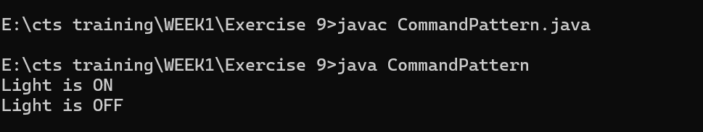

EX 10:
class Student {
private String name;
private int id;
private String grade;
public Student(String name, int id, String grade) {
this.name = name;
this.id = id;
this.grade = grade;
}
public String getName() {
return name;
}
public void setName(String name) {
this.name = name;
}
public int getId() {
return id;
}
public String getGrade() {
return grade;
}
public void setGrade(String grade) {
this.grade = grade;
}
}
class StudentView {
public void displayStudentDetails(Student student) {
System.out.println("Student Details");
System.out.println("Name : " + student.getName());
System.out.println("ID : " + student.getId());
System.out.println("Grade : " + student.getGrade());
}
}
class StudentController {
private Student model;
private StudentView view;
public StudentController(Student model, StudentView view) {
this.model = model;
this.view = view;
}
public void setStudentName(String name) {
model.setName(name);
}
public void setStudentGrade(String grade) {
model.setGrade(grade);
}
public void updateView() {
view.displayStudentDetails(model);
}
}
public class MVCPattern {
public static void main(String[] args) {
Student student = new Student("John", 101, "A");
StudentView view = new StudentView();
StudentController controller =
new StudentController(student, view);
controller.updateView();
controller.setStudentGrade("A+");

System.out.println("\nAfter Update:");
controller.updateView();
}
}
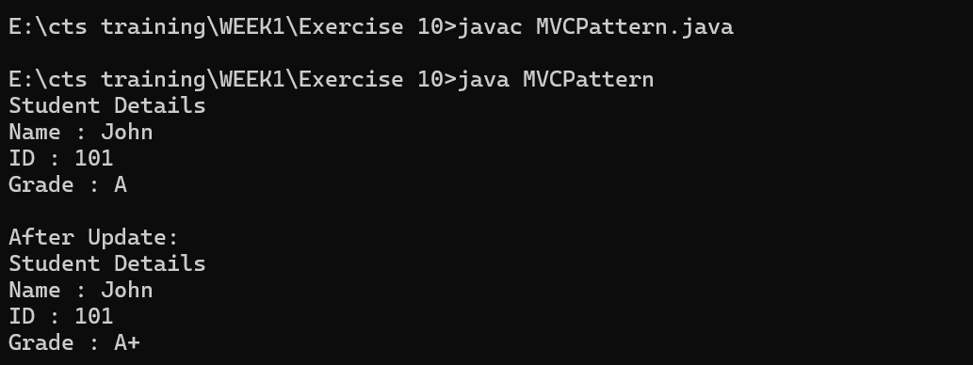
EX 11:
interface CustomerRepository {
String findCustomerById(int id);
}
class CustomerRepositoryImpl implements CustomerRepository {
public String findCustomerById(int id) {
return "Customer Found with ID: " + id;
}
}
class CustomerService {
private CustomerRepository repository;
public CustomerService(CustomerRepository repository) {
this.repository = repository;
}
public void getCustomer(int id) {
System.out.println(repository.findCustomerById(id));
}
}

public class DependencyInjection {
public static void main(String[] args) {
CustomerRepository repository =
new CustomerRepositoryImpl();
CustomerService service =
new CustomerService(repository);
service.getCustomer(101);
}
}
